

KINNAIRD COLLEGE FOR WOMEN UNIVERSITY

ANALYSIS OF ALGORITHMS
Post-Midterm Implementation Assignment
Network Bandwidth Allocation using Greedy and Dynamic Programming

Group Members:
Huda Zahid (F24BSCS014),
Insha Rukhsar (F24BSCS036)

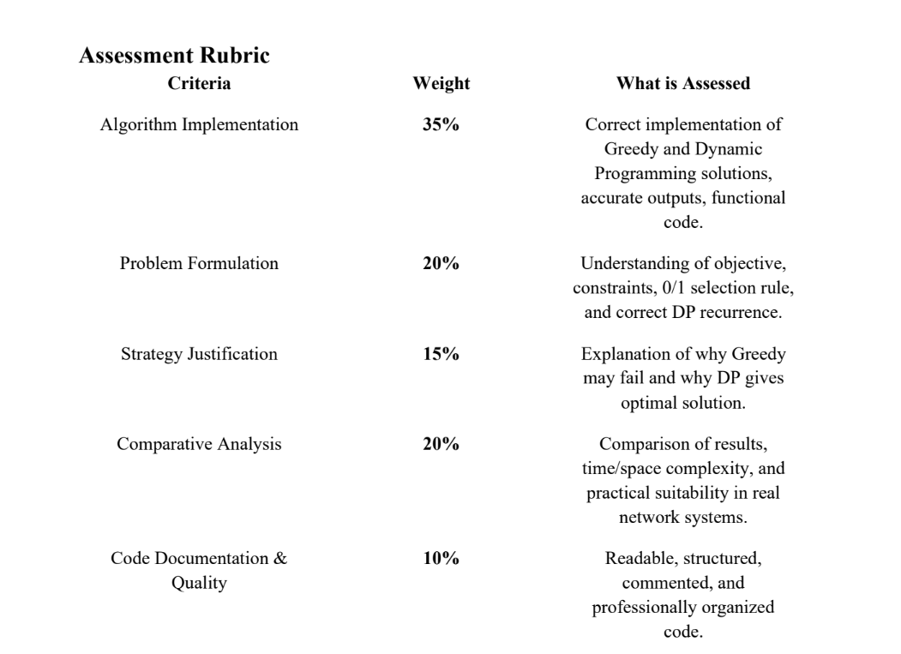

1. Background and Industry Context
Telecom companies, Internet Service Providers (ISPs), cloud services, and business networks often have limited bandwidth that must be shared among different services such as video streaming, voice calls, IoT devices, online gaming, backups, and web browsing. Managing this bandwidth efficiently is an important real-world technology and industry challenge related to network performance and Quality of Service (QoS).
In this assignment, a simplified version of this situation is studied and two algorithm design approaches are implemented: Greedy and Dynamic Programming.

2. Problem Statement
A telecom router has a maximum available bandwidth of 10 Mbps. Multiple services request bandwidth at the same time. Each service has a bandwidth requirement and a priority score. Higher priority means the service is more valuable to customer experience or network performance.
Each service can either be fully selected or rejected. Partial allocation is not allowed. The goal is to choose services so that total bandwidth does not exceed 10 Mbps and total priority is maximised.

Service ID | Bandwidth (Mbps) | Priority Score
S1 | 4 | 8
S2 | 1 | 3
S3 | 5 | 9
S4 | 3 | 6
S5 | 2 | 4
S6 | 3 | 5

Task A: Greedy Algorithm

C++ Implementation

#include <iostream>
using namespace std;

struct Service
{
string id;
int bandwidth;
int priority;
double ratio;
};

// Swap used in selection sort
void swap(Service& a, Service& b)
{
Service temp = a;
a = b;
b = temp;
}

// Selection sort by ratio (descending)
void sortByRatio(Service arr[], int n)
{
for (int i = 0; i < n - 1; i++)
{
int maxIdx = i;
for (int j = i + 1; j < n; j++)
{
if (arr[j].ratio > arr[maxIdx].ratio)
{
maxIdx = j;
}
}
if (maxIdx != i)
{
swap(arr[i], arr[maxIdx]);
}
}
}

int main()
{
const int n = 6;
int capacity = 10;

Service services[n] =
{
{"S1", 4, 8, 0},
{"S2", 1, 3, 0},
{"S3", 5, 9, 0},
{"S4", 3, 6, 0},
{"S5", 2, 4, 0},
{"S6", 3, 5, 0}
};

// Step 1: Compute priority/bandwidth ratio
for (int i = 0; i < n; i++)
{
services[i].ratio = (double)services[i].priority / services[i].bandwidth;
}

// Step 2: Sort by ratio (descending)
sortByRatio(services, n);

// Step 3: Greedy selection
string selected[n];
int count = 0;
int totalBandwidth = 0;
int totalPriority = 0;

for (int i = 0; i < n; i++)
{
if (totalBandwidth + services[i].bandwidth <= capacity)
{
selected[count++] = services[i].id;
totalBandwidth += services[i].bandwidth;
totalPriority += services[i].priority;
}
}

// Step 4: Output
cout << "Selected Services: ";
for (int i = 0; i < count; i++)
{
cout << selected[i] << " ";
}
cout << endl;
cout << "Total Bandwidth Used: " << totalBandwidth << endl;
cout << "Total Priority: " << totalPriority << endl;

return 0;
}

2. Manual Computation (Capacity = 10)

2.1 Step 1 & 2: Compute Ratios and Sort Descending
Each column represents one service after computing Priority/Bandwidth and sorting from highest to lowest ratio:

Attribute | S2 | S1 | S4 | S5 | S3 | S6
Priority | 3 | 8 | 6 | 4 | 9 | 5
Bandwidth | 1 | 4 | 3 | 2 | 5 | 3
P/B Ratio | 3 | 2 | 2 | 2 | 1.8 | 1.6

2.2 Step 3: Greedy Selection Table
Services are evaluated in sorted order. A service is selected if its bandwidth fits within the remaining capacity. Green = selected, Red = skipped.

Service | Priority | Bandwidth | Remaining BW
S2 | 3 | 1 | 9
S1 | 8 | 4 | 5
S4 | 6 | 3 | 2
S5 | 4 | 2 | 0
S3  (not selected) | 9 | 5 | 0
S6  (not selected) | 5 | 3 | 0

2.3 Final Result (Greedy)
Metric | Value
Selected Services | S2, S1, S4, S5
Total Bandwidth Used | 10 / 10 Mbps
Total Priority Score | 21

Program Output

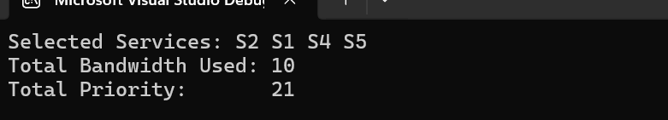

Task B: Dynamic Programming (0/1 Knapsack)

1. C++ Implementation
#include <iostream>
#include <iomanip>

using namespace std;

int main() {

int n = 6;
int W = 10;

int weight[] = { 4, 1, 5, 3, 2, 3 }; // Bandwidths
int value[] = { 8, 3, 9, 6, 4, 5 }; // Priority scores
int dp[7][11]; // DP Table

// Initialize table with 0
for (int i = 0; i <= n; i++) {
for (int w = 0; w <= W; w++) {
dp[i][w] = 0;
}
}

// Fill DP table
for (int i = 1; i <= n; i++) {

for (int w = 0; w <= W; w++) {

// Exclude current service
dp[i][w] = dp[i - 1][w];

// Include current service if possible
if (weight[i - 1] <= w) {

int include =
value[i - 1] +
dp[i - 1][w - weight[i - 1]];

if (include > dp[i][w]) {
dp[i][w] = include;
}
}
}
}

// Print DP Table
cout << endl;
cout << "DP TABLE:" << endl << endl;

cout << setw(6) << "W->";
for (int w = 0; w <= W; w++) {
cout << setw(5) << w;
}
cout << endl;

cout << setw(6) << "-----";
for (int w = 0; w <= W; w++) {
cout << setw(5) << "----";
}
cout << endl;

for (int i = 0; i <= n; i++) {

// FIXED consistent alignment for row labels
if (i == 0)
cout << setw(6) << "S0";
else {
cout << setw(5) << "S" << i;
}

for (int w = 0; w <= W; w++) {
cout << setw(5) << dp[i][w];
}

cout << endl;
}

// Maximum priority
cout << endl;
cout << "Maximum Priority Score = "
<< dp[n][W] << endl;

// Backtracking for selected services
int w = W;
cout << "Selected Services: ";

for (int i = n; i > 0; i--) {

if (dp[i][w] != dp[i - 1][w]) {

cout << "S" << i << " ";

w = w - weight[i - 1];
}
}

cout << endl;
return 0;
}

2. DP Table (Capacities 0 → 10)
Each row shows the maximum achievable priority for services 1..i at every capacity 0-10.The cell dp[S6][10] = 21 is the optimal answer.

W → | 0 | 1 | 2 | 3 | 4 | 5 | 6 | 7 | 8 | 9 | 10
0 | 0 | 0 | 0 | 0 | 0 | 0 | 0 | 0 | 0 | 0 | 0
S1 | 0 | 0 | 0 | 0 | 8 | 8 | 8 | 8 | 8 | 8 | 8
S2 | 0 | 3 | 3 | 3 | 8 | 11 | 11 | 11 | 11 | 11 | 11
S3 | 0 | 3 | 3 | 3 | 8 | 11 | 12 | 12 | 12 | 17 | 20
S4 | 0 | 3 | 3 | 6 | 9 | 11 | 12 | 14 | 17 | 18 | 20
S5 | 0 | 3 | 4 | 7 | 9 | 11 | 13 | 15 | 17 | 18 | 21
S6 | 0 | 3 | 4 | 7 | 9 | 11 | 13 | 15 | 17 | 18 | 21

3. Backtracking: Service Selection
Starting from dp[S6][10] = 21 we trace back: if dp[i][w] differs from dp[i-1][w] then service Si was included and w decreases by its bandwidth.

Service | dp[i][w] | dp[i-1][w] | Included? | New w
S6 | 21 | 21 | No | 10
S5 | 21 | 20 | Yes | 8
S4 | 17 | 12 | Yes | 5
S3 | 11 | 11 | No | 5
S2 | 11 | 8 | Yes | 4
S1 | 8 | 0 | Yes | —

4. Program Output
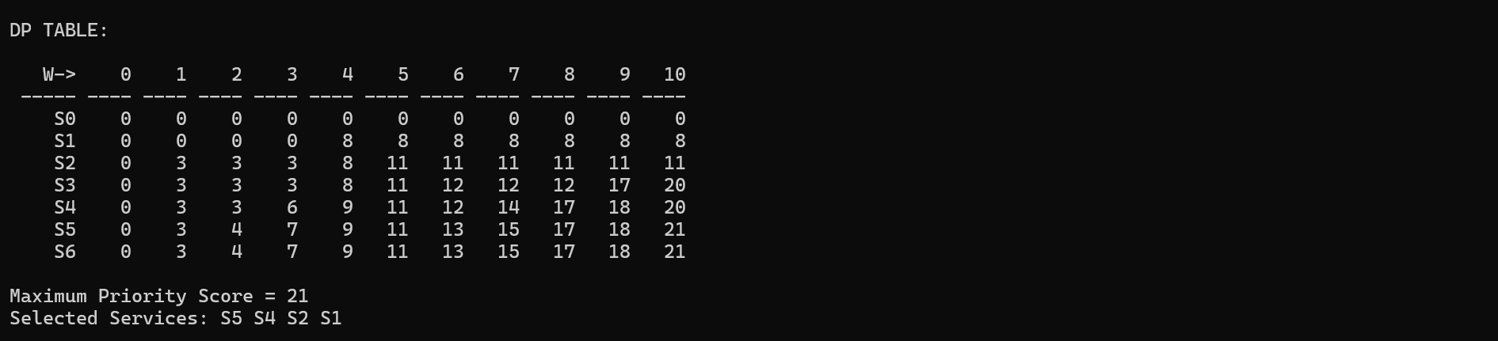

5. Final Result (DP)
Metric | Value
Selected Services | S5, S4, S2, S1
Total Bandwidth Used | 2 + 3 + 1 + 4 = 10 Mbps
Total Priority Score | 21 (Globally Optimal)

Task C: Comparison and Design Reasoning
In this assignment, two algorithmic approaches were implemented to solve the same bandwidth allocation problem: the Greedy Algorithm and Dynamic Programming (0/1 Knapsack). While both approaches aim to maximize total priority under a bandwidth constraint of 10 Mbps, they differ significantly in their decision-making strategy and optimality guarantee.

Greedy Algorithm Approach
The Greedy algorithm works by calculating the priority-to-bandwidth ratio for each service and then selecting services in descending order of this ratio. At each step, the algorithm makes a locally optimal decision by choosing the service that provides the highest immediate benefit relative to its cost (bandwidth), without reconsidering previous selections.
This approach is efficient and simple, as it does not require exploring all possible combinations. However, its major limitation is that it is short-sighted, meaning it focuses only on immediate gain rather than the overall optimal combination. Once a service is selected or rejected, the decision is final, even if a better combination exists later.

Dynamic Programming Approach
In contrast, the Dynamic Programming (DP) approach solves the problem using a systematic exploration of all possible combinations of services. It builds a table that considers two choices at every step:
- Including the current service (if bandwidth allows)
- Excluding the current service
By evaluating both possibilities for every subproblem, DP ensures that no potential combination is ignored. It then selects the combination that yields the maximum total priority while respecting the bandwidth constraint.
Unlike Greedy, DP does not rely on immediate benefit alone. Instead, it considers the global structure of the problem, ensuring an optimal solution.

1. Output Comparison
Metric | Greedy Algorithm | Dynamic Programming
Selected Services | S2, S1, S4, S5 | S5, S4, S2, S1
Total Bandwidth | 10 / 10 Mbps | 10 / 10 Mbps
Total Priority | 21 | 21 (Optimal)
S3 Selected? | No | No
S6 Selected? | No | No
Guarantee Optimal? | Not always | Always
Time Complexity | O(n log n) | O(n × W)
Space Complexity | O(n) | O(n × W)

2. Why Greedy May Fail for 0/1 Knapsack
The Greedy algorithm always makes the best-looking choice at the moment, meaning it selects the service with the highest priority-to-bandwidth ratio first.This works well for problems where items can be split (like fractional knapsack), but it does not always work for 0/1 knapsack because we either take a service completely or not at all.
Greedy can fail due to the following reasons:
- Irreversible decisions: Once a high-ratio service is selected, we cannot undo it. This may use up bandwidth that could have been better used in a different combination of services.
- Does not consider combinations: Greedy only looks at individual services, not how multiple smaller services together might give a better total priority.
- Wasted leftover space: After selecting a service, the remaining bandwidth may be too small for other useful services, even if a better overall combination exists.

Simple Example
Capacity = 5
- A: bandwidth = 4, priority = 5 (ratio = 1.25)
- B: bandwidth = 3, priority = 4 (ratio = 1.33)
Greedy picks B first because it has a higher ratio.
Now only 2 units of bandwidth are left, so A cannot be selected.
- Greedy result = 4
- Better choice = A alone gives 5
So Greedy gives a worse result in this case.

3. Why Dynamic Programming Always Gives the Optimal Solution
Dynamic Programming (DP) guarantees the best solution because it does not rely on one decision. Instead, it checks all possibilities in a structured way.
It works based on these ideas:
- Optimal substructure:
The best solution for a problem is built using the best solutions of smaller subproblems.
- No repeated work:
DP stores results of subproblems in a table, so it does not recompute them again. This makes it efficient.
- No early decisions:
DP does not commit to a choice too early. It considers both options (take or skip) for every service.
- Complete checking:
By filling the DP table, it effectively considers all possible combinations and ensures the best one is chosen.
So, DP always finds the maximum possible total priority within the bandwidth limit.

Task D: Conclusion
This assignment compared Greedy and Dynamic Programming approaches for the bandwidth allocation problem using the 0/1 Knapsack model.
The Greedy algorithm is fast and simple, but it does not always guarantee an optimal solution because it makes decisions based on immediate benefit only. Dynamic Programming, however, checks all possible combinations and always produces the optimal result, although it requires more computation.
In this case, both methods gave the same result (total priority = 21), but this was coincidental.
This work helped in understanding the difference between local optimization (Greedy) and global optimization (DP). It also showed how such algorithms are used in real systems like telecom networks, cloud services, and ISPs to efficiently manage limited resources like bandwidth.
These optimization techniques help improve system performance and ensure fair resource distribution among multiple users in real-time environments.

